**ACTIVITY DIAGRAMS FOR TRADE GAME**

**G. SuryaDev Reddy** : 14CO214 : gouru.surya@gmail.com 8123997429

**Yathish Reddy M** : 14CO254 : yathish13mreddy@gmail.com 9448505272

**Srihari B T** : 14CO256 : srihari915@gmail.com 9482947011

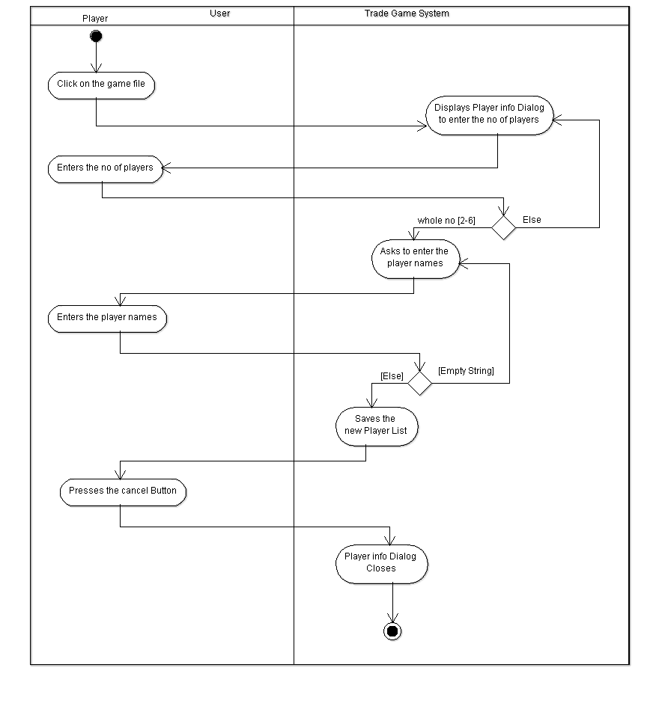

**UC1 Enter the Player Info**

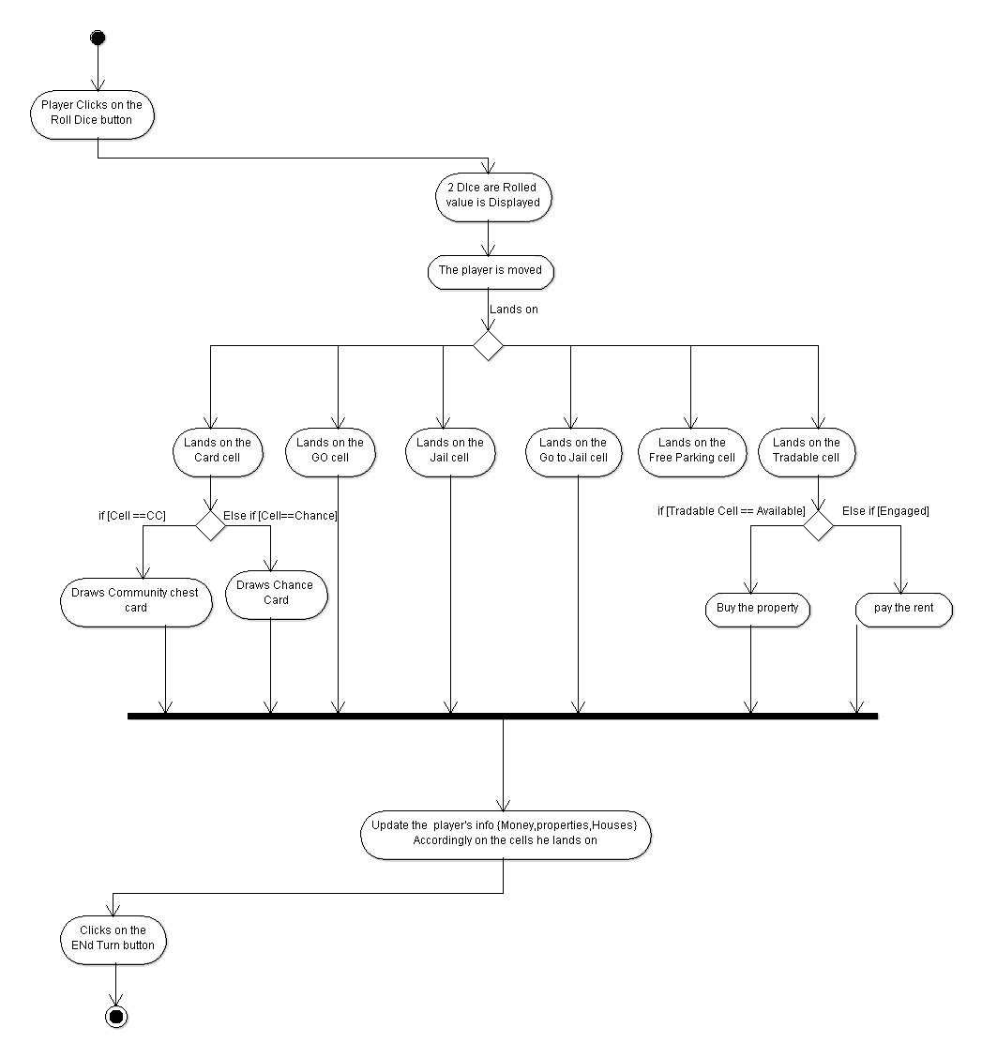

**UC2 ‘Roll the Dice’**

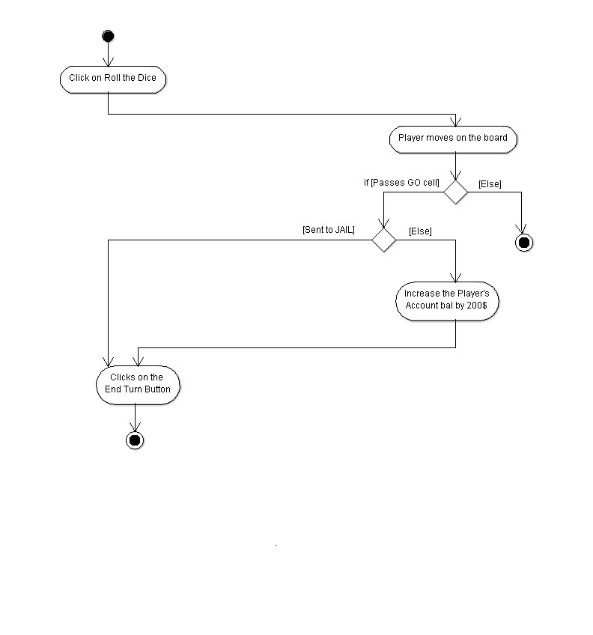**UC3: ‘PASS GO ‘cell**

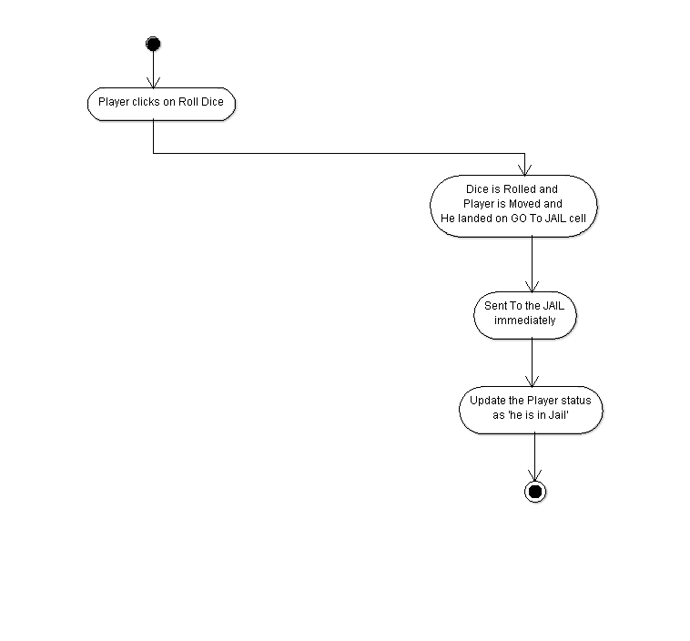

**UC5 : ‘Go to Jail’ 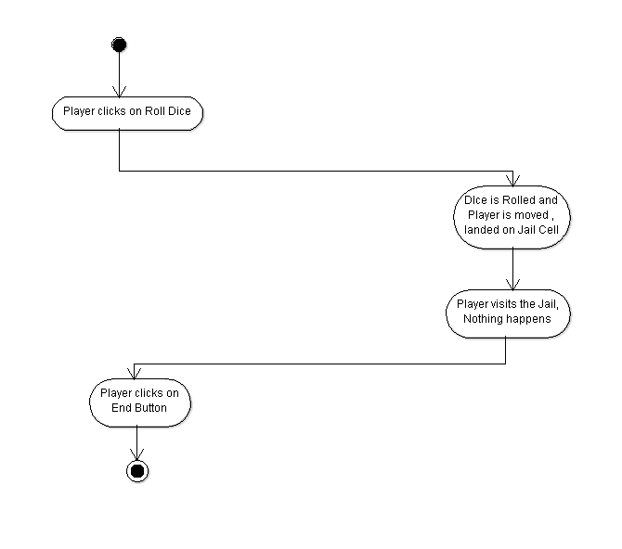 UC6 UC 6 : ‘VISIT JAIL’ 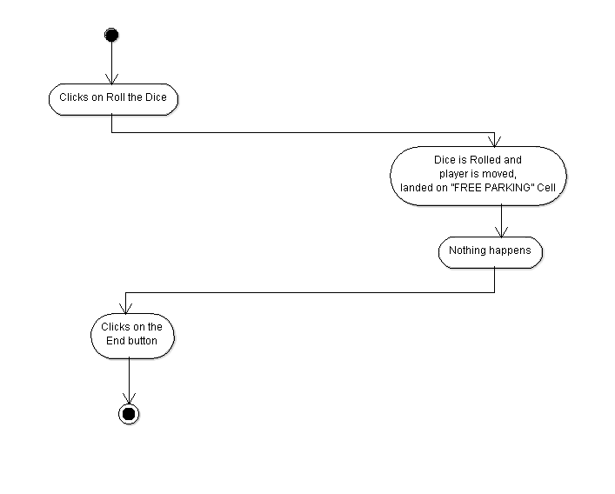UC7 ‘Go to FREE Parking’ 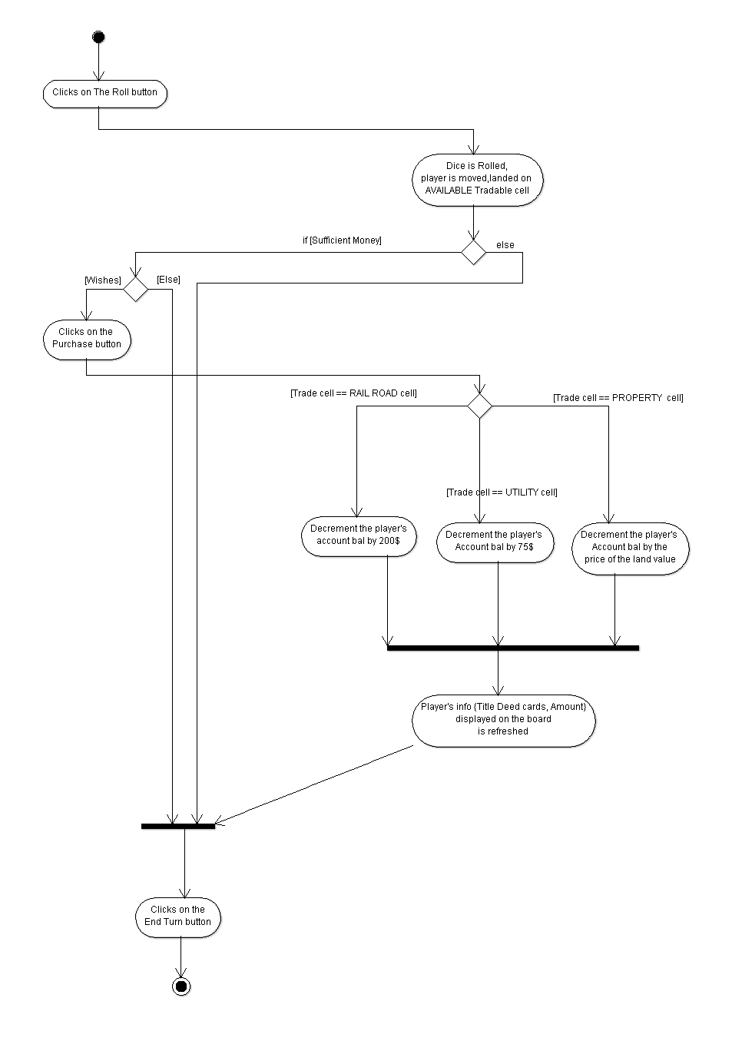UC8 : ‘Purchase Tradable Cell’**

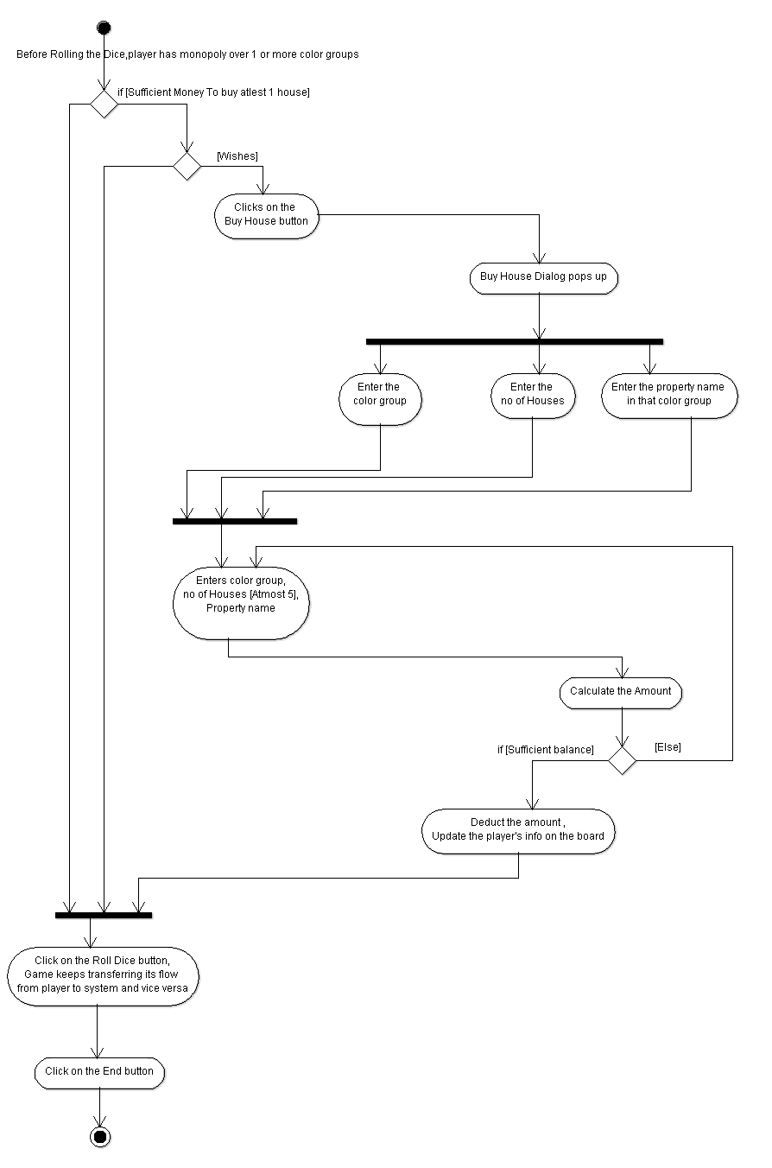**UC9 ‘BUY HOUSE’ 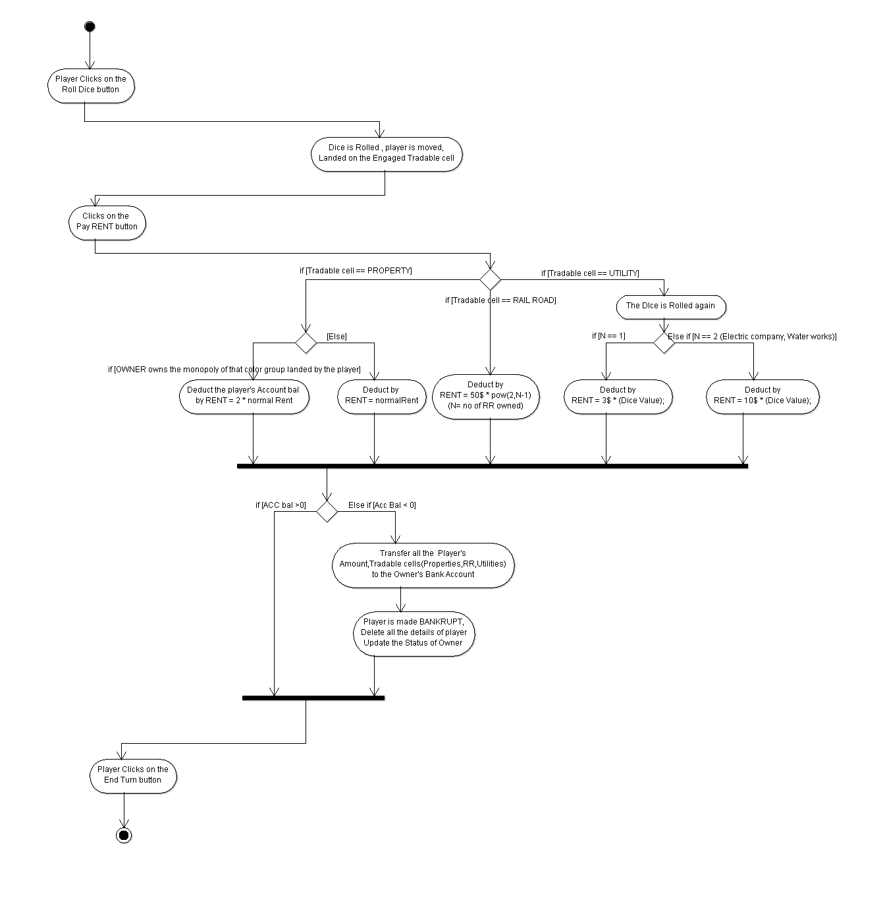UC10 ‘Pay RENT’**

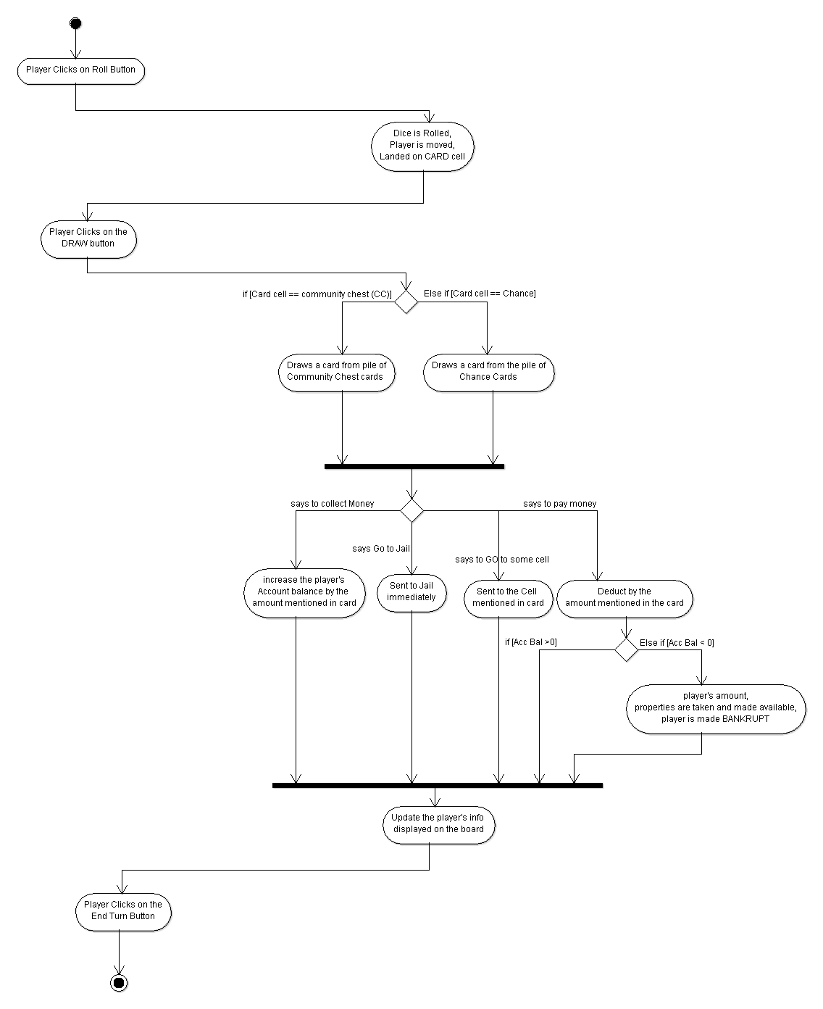**UC11 DRAW CARD**

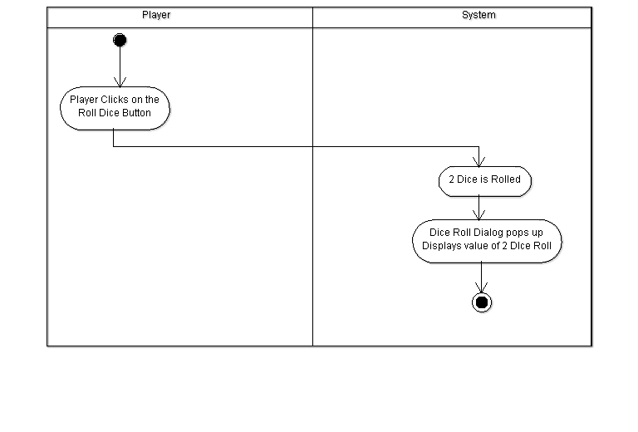**UC12 : ROLL DICE**

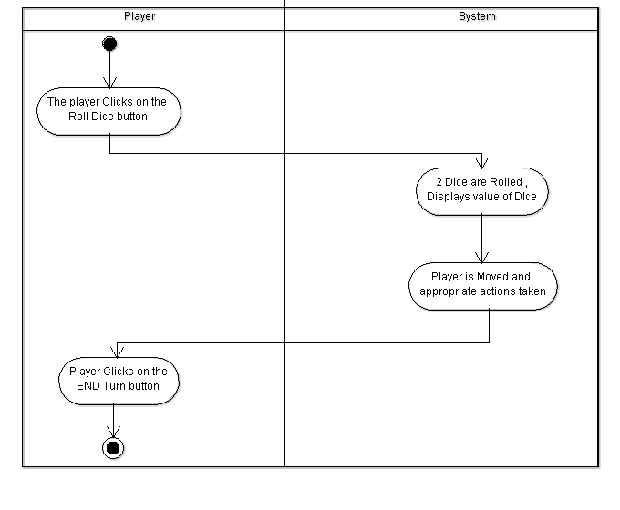**UC13: Switch Turn**

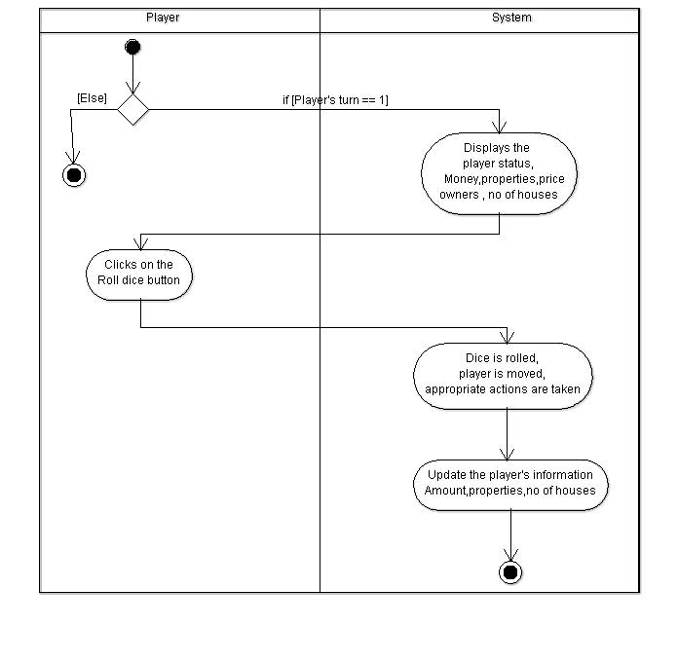**UC14 : View Information**

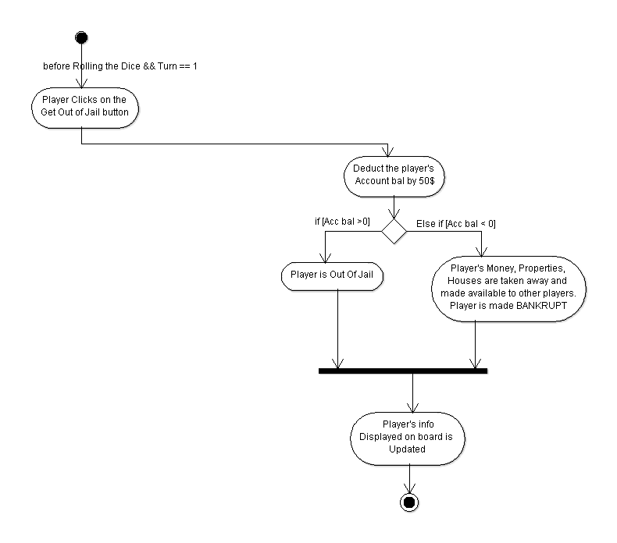**UC15 :Get Out of Jail 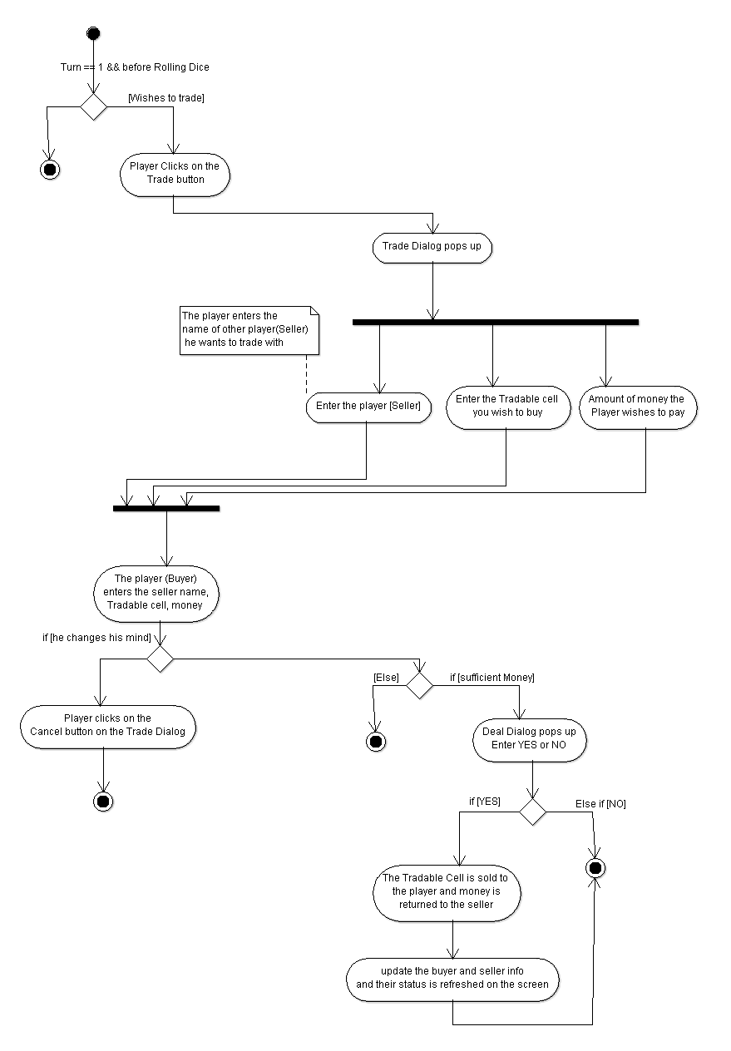 UC16 : Trade**